MULTISITE GRANT MANAGEMENT SYSTEM

MHRD (NME ICT) -Proposal Submission

User Guide Document

-MGMS Ver. 1.8-

Version History
Date | Description
01-Feb-2010 | First Draft
28-Feb-2010 | Versioning for re-submitted proposals

Table of Contents

Version History 2
1 Introduction 5
2 Internal Proposal Evaluation 5
2.1 Application form 6
2.1.1 Part I 8
2.1.2 Part II 8
2.1.3 Part III 10
2.1.4 Part IV 11
2.1.5 Part V 13
2.1.6 Part VI 14
2.1.7 Part VII 14
2.1.8 Preview Page 15

Table of Figures

Figure 1: Log-in page - Upload proposal link 6
Figure 2: Notification List 6
Figure 3: Notification Details 7
Figure 4: Upload MHRD Sakshat proposal 7
Figure 5: Form part - I 8
Figure 6: Form part - II 9
Figure 7: Form part - III 10
Figure 8: Form part - IV 11
Figure 9: Form part - V 13
Figure 10: Form part - VI 14
Figure 11: Form part - VII 14
Figure 12: Proposal preview and submit 16
Figure 13: Public user - Proposal options after submission 16
Figure 14: Public user - Revision of submitted proposal 16

Introduction

This document provides the step-by-step instructions for the various activities associated with applying for funds to a grant agency on a pre-saved proposal application format using the Multisite Grant Management System application. These proposals are unsolicited – i.e. not in response to any published notification.

This is a ‘living document’ and the specification will change, continuously, as the project proceeds. More details will be added and the existing information edited as the requirements, architecture and design evolve in the course of the project.

Internal Proposal Evaluation

Currently the provision for applying to MHRD has been implemented.

- Anyone may apply using this form to the particular granting agency. It is not required that the applicant’s institution be already registered in MGMS.

- There is option to select institution for applying to. It is expected that different member institutions of MGMS will have different application forms.

- The form has 7 parts – where, in the 6th page – there is mandatory uploading of the PI CV and the DPR. The 7th page captures the overall summary of the entire filled up form.

- On submitting the page 7, the preview is displayed. From here edit feature is enabled.

- First page – filling up is mandatory and on saving this page, a proposal is officially created in the GMS system.

- A control ID is generated, also on saving the first page and a mail sent to the applicant’s email id confirming it. The control ID is also displayed on all subsequent pages of the application form.

- On final submission of proposal, an alert e-mail is sent to all members of the default approval authority.

- Currently versioning is provided to the extend that – the first time a form is submited, it is assigned version “v1” and after that each the same form is opened using the control ID, the version number is incremented – for e.g. v2, v3, v7 etc.

Application form

Opening new form

Figure 1: Log-in page - Upload proposal link
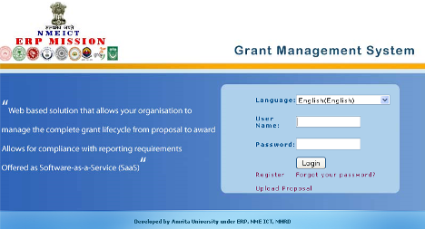

On clicking Upload Proposal in the Log in page, the following screen appears: (Clicking on Home, takes the user back to the Log in page.

Figure 2: Notification List
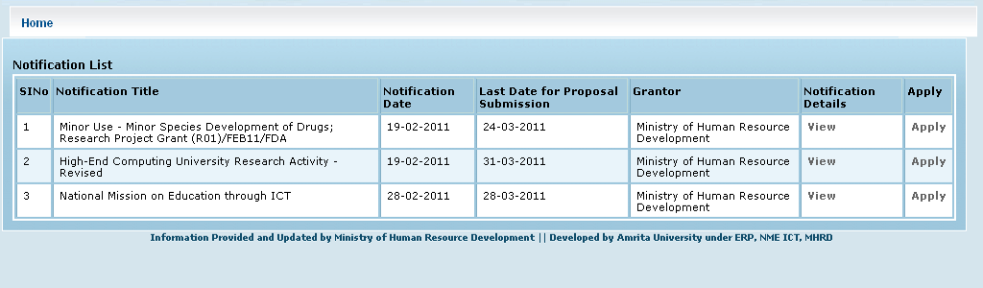

In the Notification List, all grant scheme notifications inviting proposals from the public are displayed. For example, in Fig 2 above, the grantor MHRD is inviting proposals for 3 schemes. On clicking View for a Notification, the details are displayed as shown below:
Figure 3: Notification Details
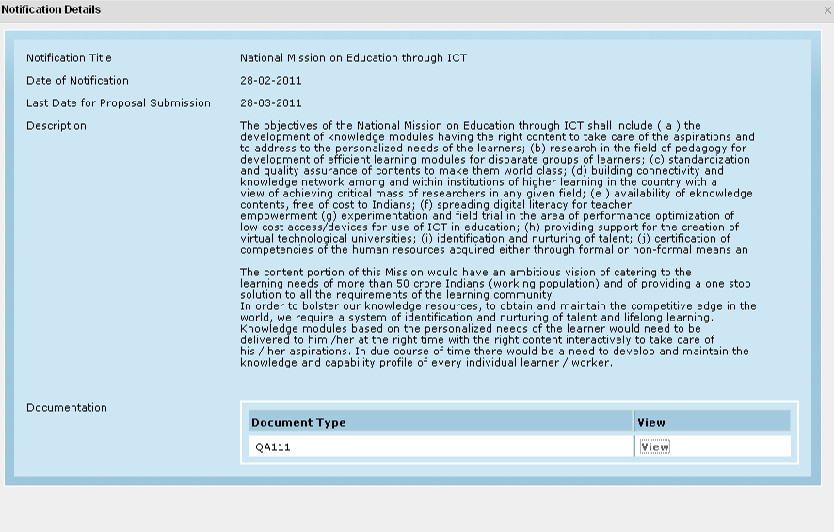
This window can be closed by clicking “x” in the top right hand corner.
To apply for a particular scheme, click “Apply” for the associated notification (Fig 2). As per current client requirement, the 7-page MHRD Sakshat form opens up for any notification.

Figure 4: Upload MHRD Sakshat proposal
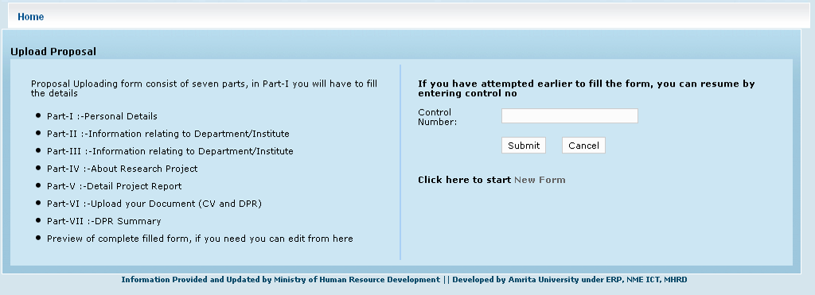
On clicking New Form, the form opens.

Part I

The first page of the 7-part form opens up. On this page all fields are mandatory.

Figure 5: Form part - I
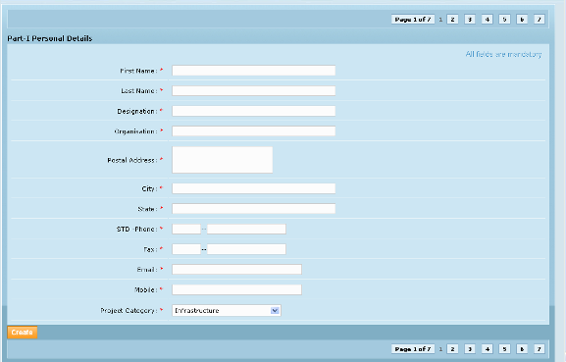

(Please note that the Project Category field displays the proposal categories saved for the particular funding agency by the site administrator)

Part II

On clicking Next in page 1 above, a control ID is generated which will be used for all further reference to this proposal at any later time. A mail is sent to the applicant.

From third page onwards, the Control ID generated is displayed at the top of every page and also the current version of the document being edited (“V1” now since this is the first draft)

Figure 6: Form part - II
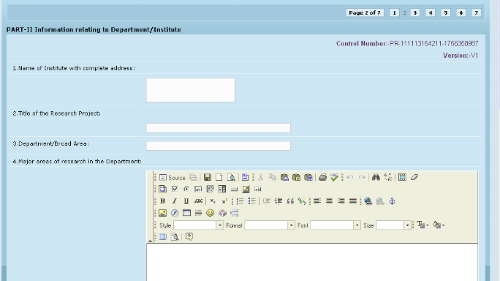

In all rich text editors, it should be possible to include tables (10-15 rows, 5-6 columns, images, graphs etc)
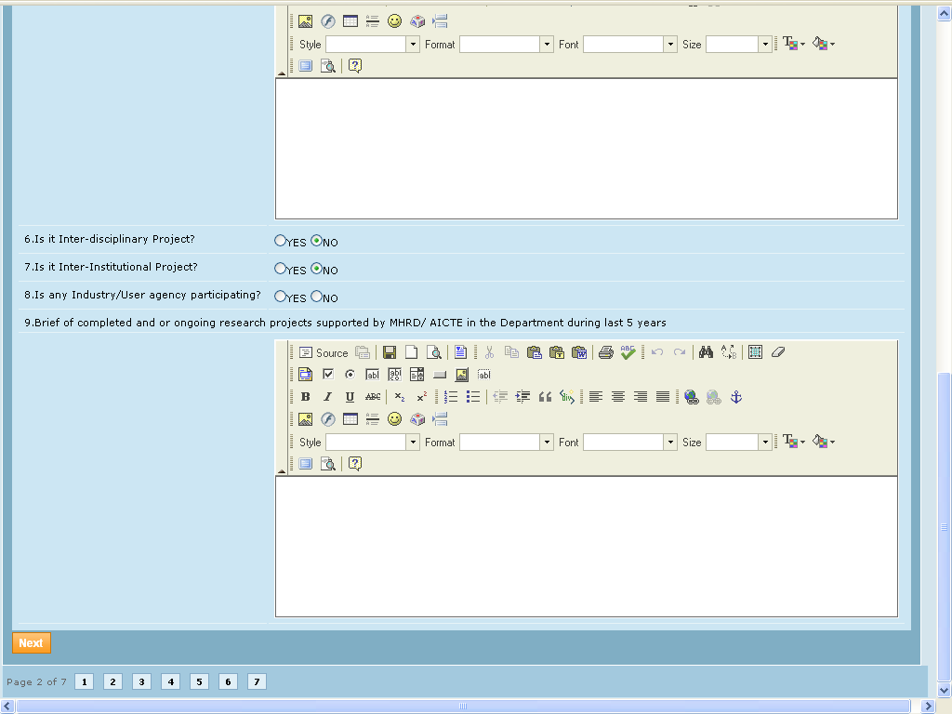

Part III

Fields are not mandatory
Figure 7: Form part - III
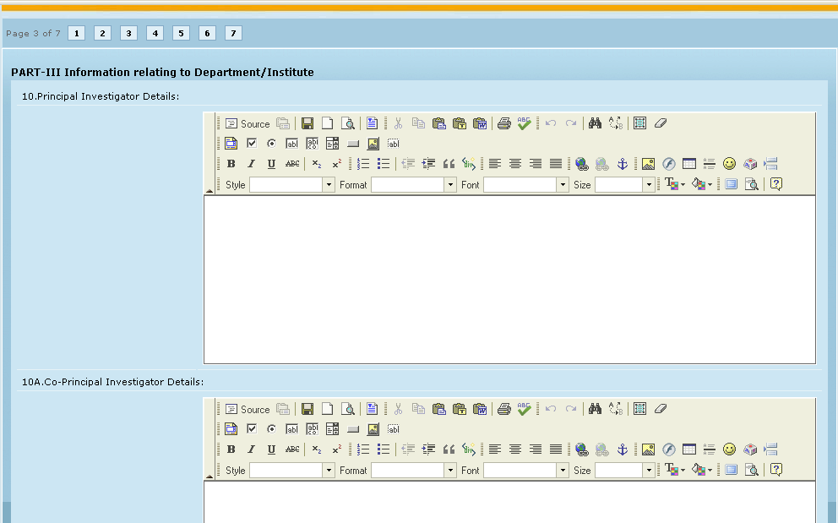

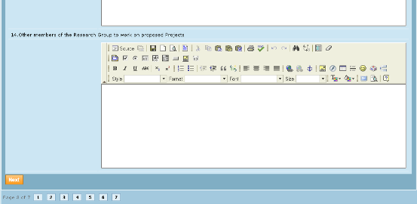

Part IV
Fields are not mandatory
Figure 8: Form part - IV
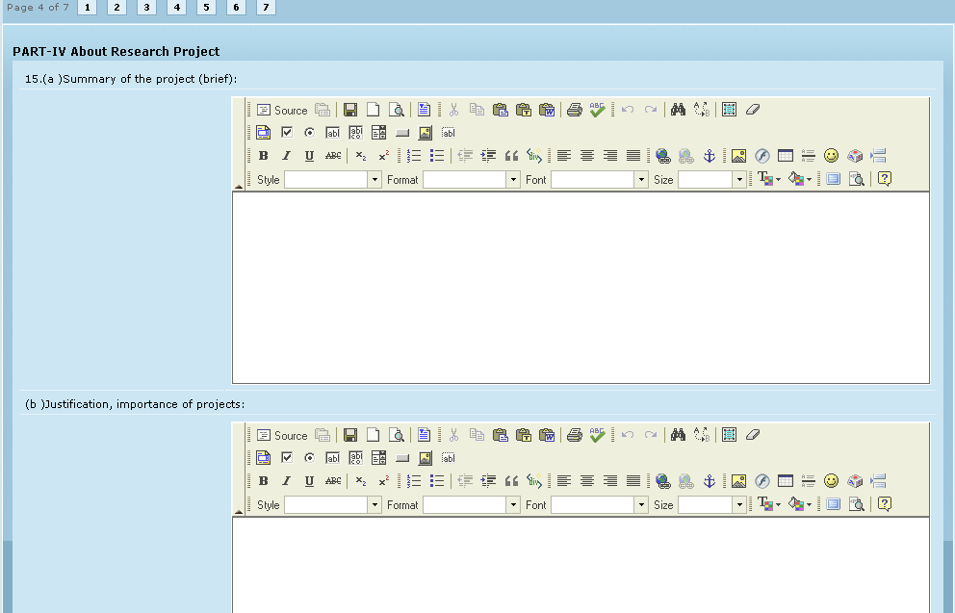

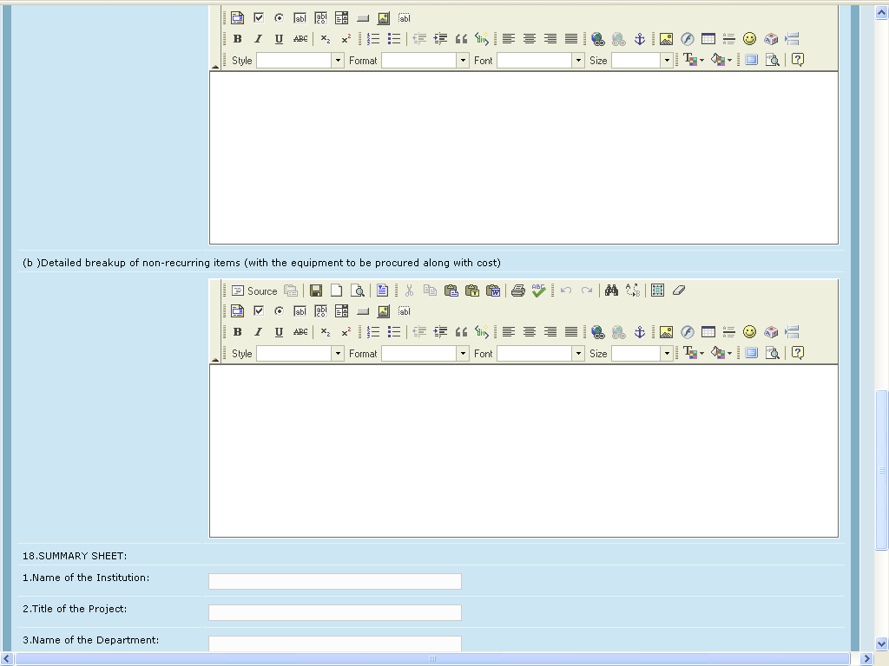
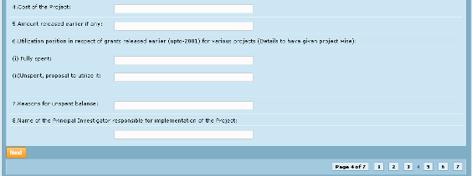

Part V
Figure 9: Form part - V
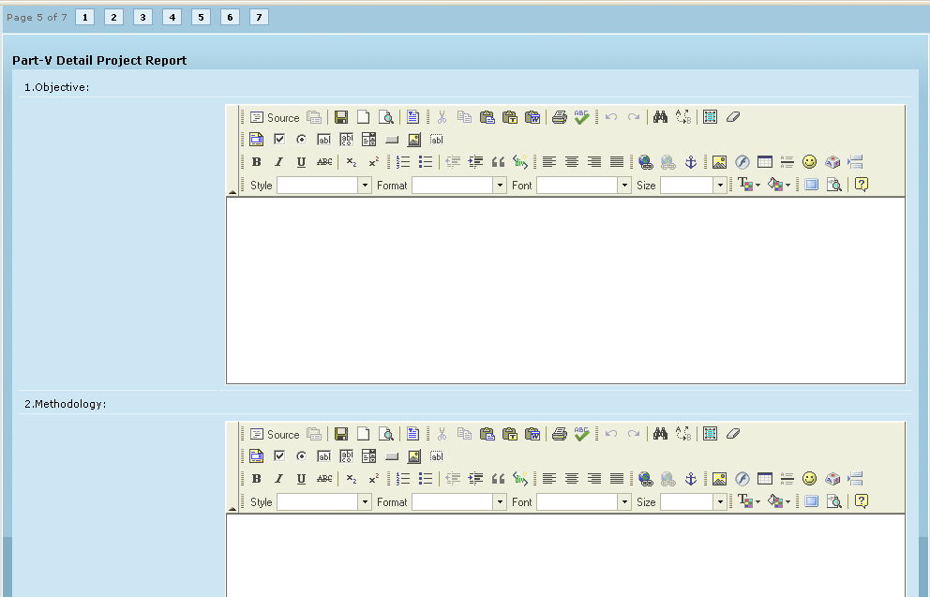

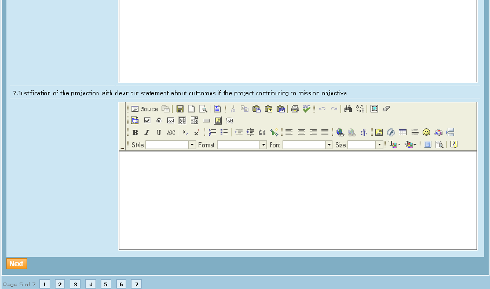

Part VI
Figure 10: Form part - VI
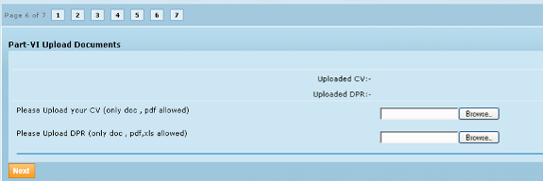

Upload of CV and DPR is mandatory.

Part VII

In page 7, all fields are mandatory
Figure 11: Form part - VII
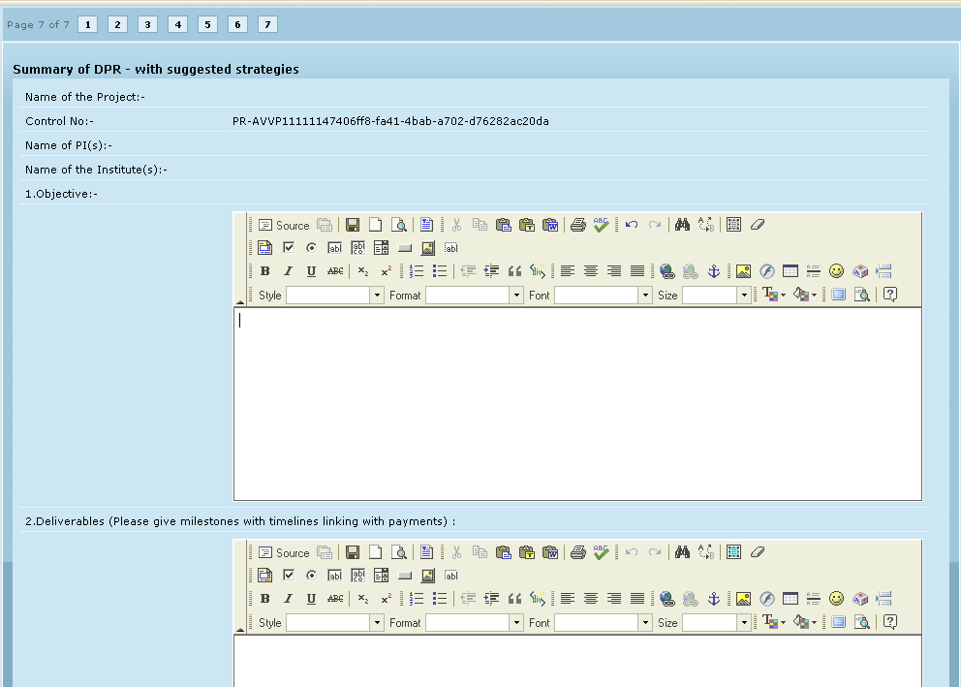
.
.
.
The page has 10 questions all requiring text editor input fields. Last 2 questions shown below
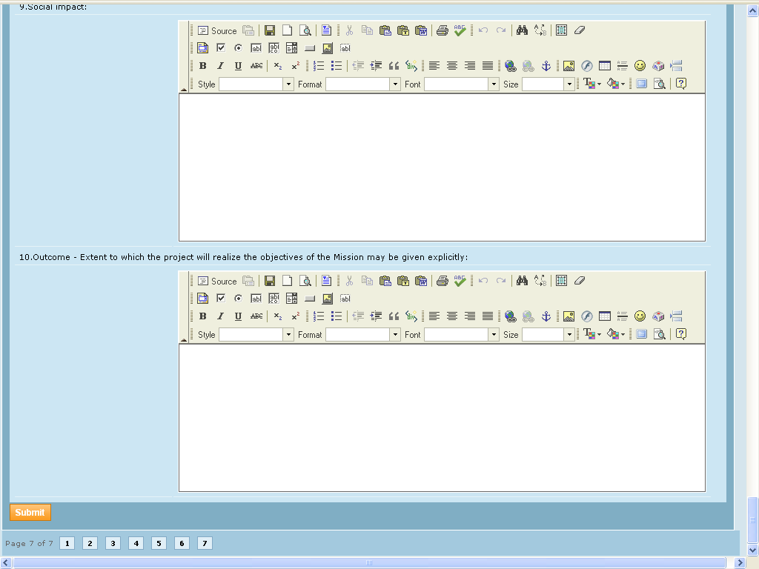

On clicking Submit in the page above, the preview of the details filled in so far, is displayed:

Preview Page

In Fig 12 below, is the preview page after filling on all 7 pages.

On clicking Edit for any section, the corresponding page opens up for editing. In that page, after editing, on clicking Update, the preview page returns displaying the changed data.

Now on clicking Finish, the proposal is officially submitted for evaluation as version V0.

On trying to open the proposal again by submitting the control id, the system displays message that it is already submitted (Fig 13) and the user is provided with 3 options (Links) –

Details provided by you – opens the Preview page
Enter revised proposal – opens Revision of Proposal screen where the user has to select “I agree” option to open the Preview – Edit page
Upload Proposal – opens new proposal form to start again

On clicking Enter revised proposal link, screen opens where the user has to select “I agree” option and click Submit to open the Preview – Edit page (Fig 14)

Figure 12: Proposal preview and submit
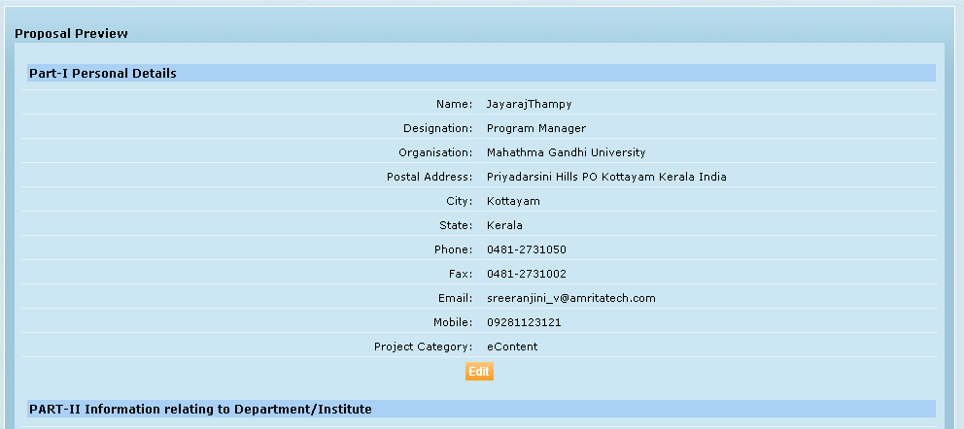

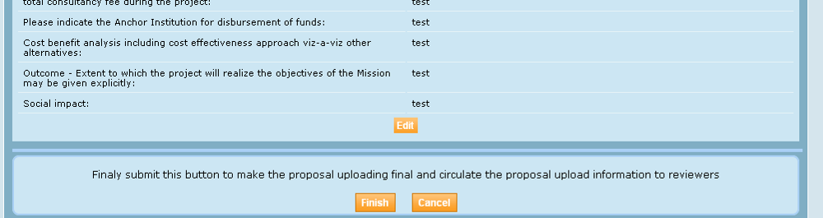

Figure 13: Public user - Proposal options after submission
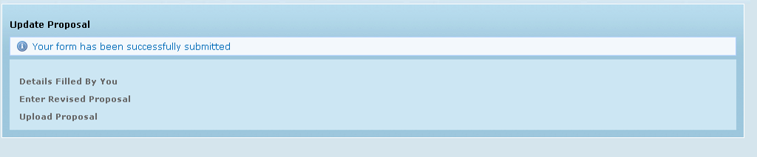

Figure 14: Public user - Revision of submitted proposal
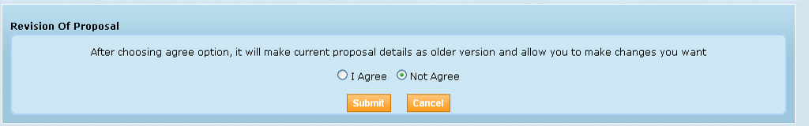
After making the necessary changes and updating the proposal, the user can click Finish. The version number of proposal changes, each time a proposal is revised in this manner.
On submission of the proposal, it is available for evaluating in the log-ins of all reviewers who are part of the institution’s default approval authority.

In the above screens, clicking on Cancel button opens the MGMS log-in page

